**Software Requirements Specification (SRS)**

Project Title: **Online Banking**

Requirements:

We need to build a software for Online banking. The application will have following features:

1. There will be different type users like Admin, senior officer, cashier, operator etc.
2. There will be account type like current account, savings account etc.
3. There will be Nominee and one account may have one or more nominees and one nominee may attach to one or more accounts.
4. Account opening balance at least 5000 BDT. And always available balance will be at least 1000 BDT
5. An account holder may have check book and every check book will have multiple pages.
6. An account holder may deposit and withdrew and transfer money.
7. An account holder may ask his account deposit summary, withdrew summary and transaction statement or bank statement.

Analysis and Design Part:

1. Brain Storming Diagram:

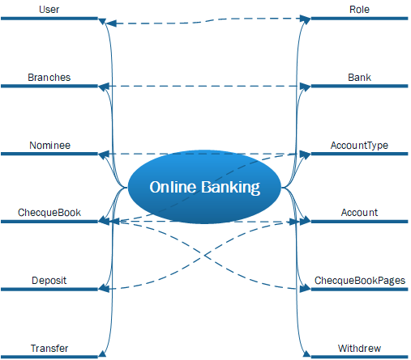

1. Use Case Diagram:
2. Class Diagram:
3. Entity Relationship Diagram:
4. Front End Designs: